AI Assisted Coding – Lab Assignment 3.5
Name:- MD.Abdul Layeeq
HT.No:- 2303A52217
Batch:- 45

Question 1: Zero-Shot Prompting (Leap Year Check)
Scenario
Testing AI’s ability to generate logic without examples.
Prompt
Generate a Python function to check whether a given year is a leap year Test with years.
Code:-
def is_leap_year(year):
if (year % 4 == 0 and year % 100 != 0) or (year % 400 == 0):
return True
else:
return False
year = int(input("Enter a year: "))
print(is_leap_year(year))

Output:-
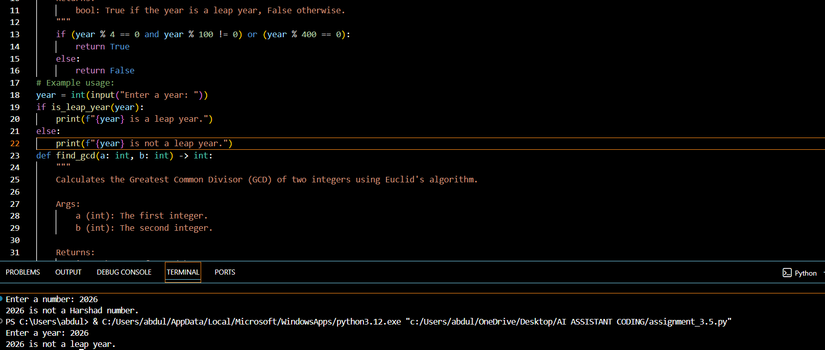

Logical Flaws / Missing Conditions
- Does not validate negative years
- No type checking
- Works correctly for leap logic
Observation: The logic was correct, but the AI did not include input validation (negative years, non-integers). Zero-shot prompting relies fully on the AI’s internal knowledge.

Question 2: One-Shot Prompting (GCD)
Prompt (One-Shot)
Generate a Python function to find GCD of two numbers.
Code:-
def gcd(a, b):
while b:
a, b = b, a % b
return a

a = int(input("Enter first number: "))
b = int(input("Enter second number: "))
print("GCD of", a, "and", b, "is", gcd(a, b))
OUTPUT:-
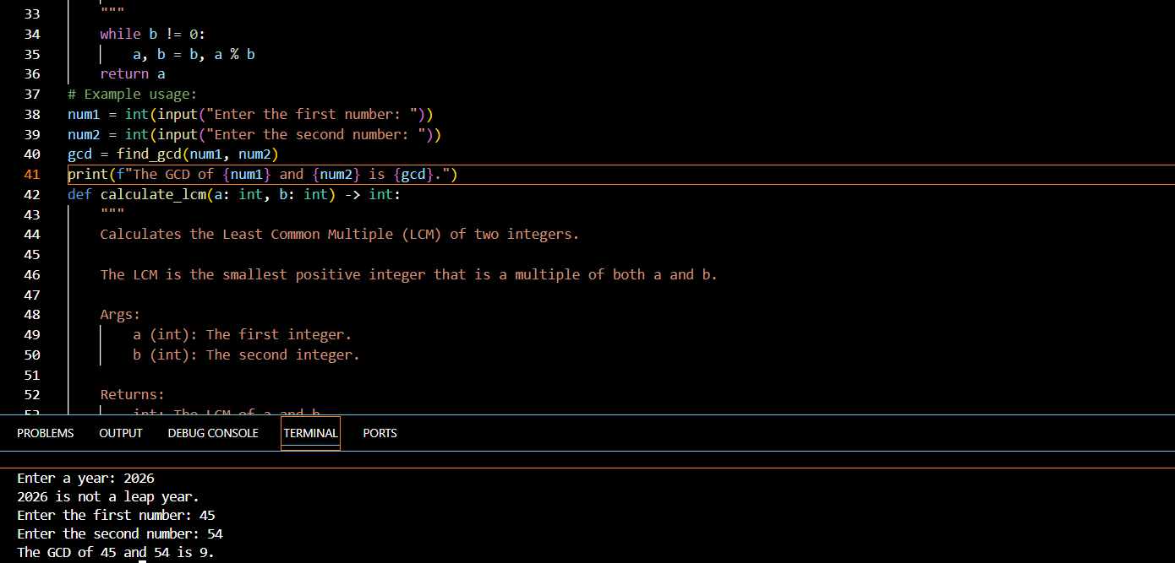

Zero-Shot Comparison
Zero-shot often gives subtraction method (slower). One-shot leads to Euclidean algorithm.

Efficiency
Time Complexity: O(log n) (efficient)
Observation: Compared to zero-shot (which might use repeated subtraction), one-shot prompting improved algorithm selection. Efficiency is O(log n), making it faster and more optimized.

Question 3: Few-Shot Prompting (LCM)
Prompt :-
Generate a Python function to find LCM of two numbers.
Code:-
from math import gcd
def lcm(a, b):
return (a * b) // gcd(a, b)

a = int(input("Enter first number: "))
b = int(input("Enter second number: "))
print("LCM of", a, "and", b, "is", lcm(a, b))
Output:-
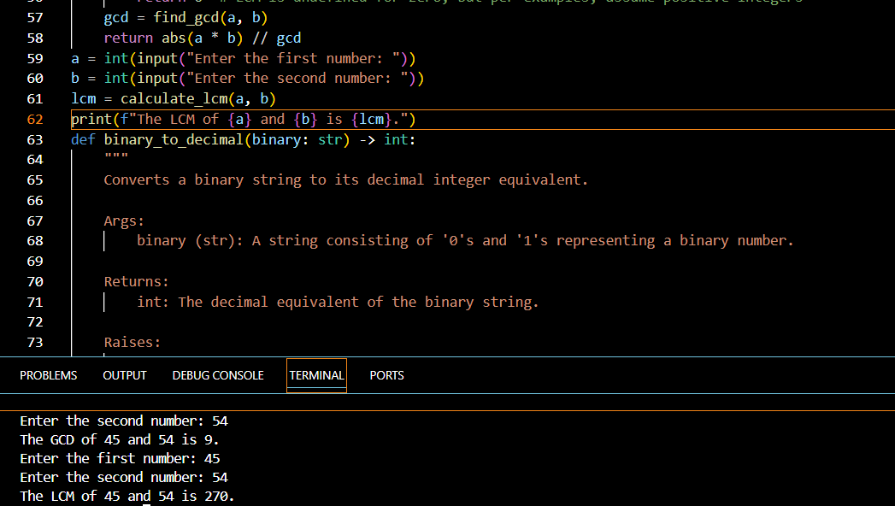
Edge Cases
- Works for positive numbers
- Needs handling for zero
Observation: Few-shot prompting strongly influenced the correct formula choice. However, edge cases like LCM with zero were not handled. Examples help AI identify patterns more accurately.

Question 4: Zero-Shot (Binary to Decimal)
Prompt
Generate Python function to convert binary to decimal

Code:-
def binary_to_decimal(binary_str):
return int(binary_str, 2)
binary_str = input("Enter a binary number: ")
decimal_number = binary_to_decimal(binary_str)
print("Decimal equivalent:", decimal_number)
Output:-
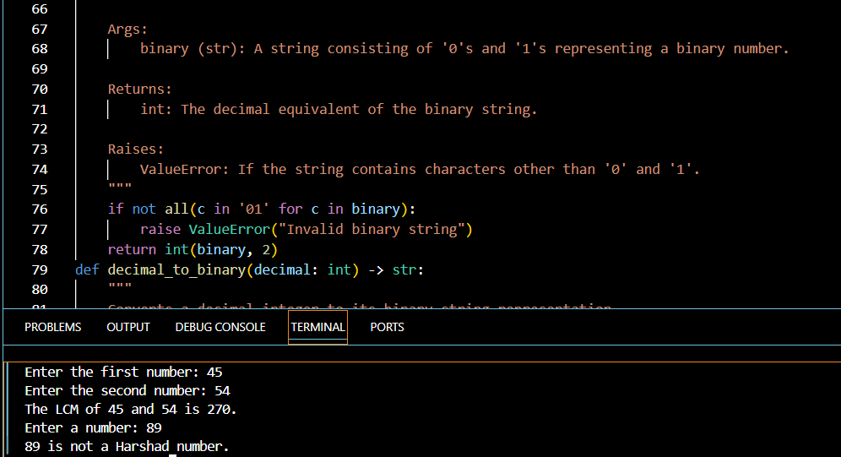
Missing Validation
- No check for invalid characters
- Crashes on wrong input
Observation: While the logic is correct, the AI did not include validation to ensure the input contains only ‘0’ and ‘1’. Invalid inputs can cause runtime errors. Zero-shot solutions often miss error handling.

Question 5: One-Shot (Decimal to Binary)
Prompt
Generate a Python function that converts a decimal number into its binary representation. The function should return the binary value as a string.Also ensure the function handles the case when the number is 0.

Code:-
def decimal_to_binary(decimal_num):
if decimal_num == 0:
return "0"
binary_str = ""
while decimal_num > 0:
binary_str = str(decimal_num % 2) + binary_str
decimal_num //= 2
return binary_str

decimal_num = int(input("Enter a decimal number: "))
binary_representation = decimal_to_binary(decimal_num)
print("Binary equivalent:", binary_representation)
Output:-
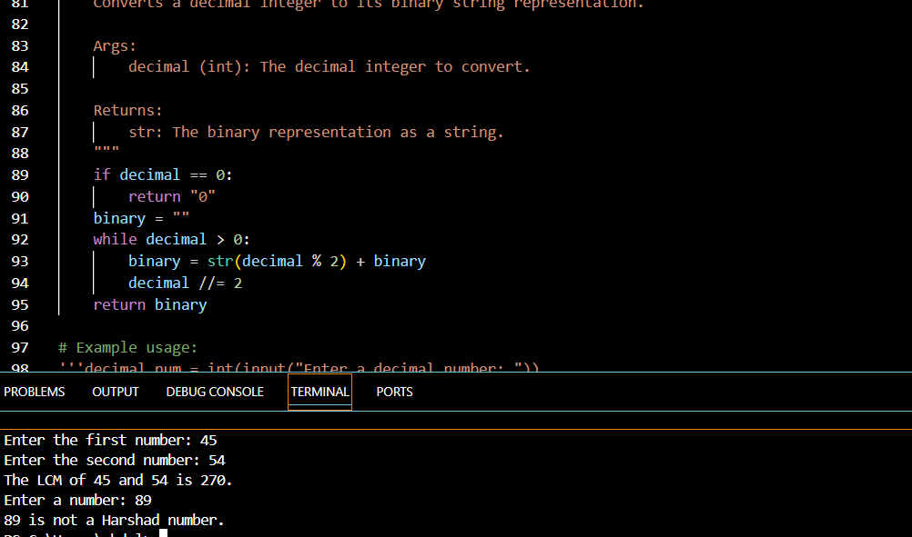
Analysis
- Zero works
- Negative numbers show “-0b” (needs handling)
Observation: The AI handled normal numbers and zero properly. However, negative numbers produce outputs like “-1010”, which was not explicitly addressed. One-shot prompting improves format accuracy.

Question 6: Few-Shot (Harshad Number)
Prompt
Generate a Python function that checks whether a number is a Harshad (Niven) number. A Harshad number is divisible by the sum of its digits. The function should return an appropriate message.
Code:-
def is_harshad_number(num):
if num == 0:
return False
digit_sum = sum(int(digit) for digit in str(num))
if num % digit_sum == 0:
return f"{num} is a Harshad number."
else:
return f"{num} is not a Harshad number."

num = int(input("Enter a number: "))
print(is_harshad_number(num))
Output:-

Boundary Conditions
- Needs zero handling
- Negative number handling missing
Observation: The logic works correctly for positive numbers. However, zero and negative numbers were not handled. Few-shot prompting helped AI learn rule-based logic effectively.

